Report on DEPEC Workshop held in the Hai district, Moshi January 10th -12th 2018

Day 1
Core team meeting/mini workshop
This was attended by Aloyce Kisoli (specialist nurse Msc) Dr Kisima (assistant medical officer and coordinator of Hai dementia prevalence studies) Dr Ali Jane Rogathe (senior nurse/PhD student with psychiatry experience), Ssenku Safic (psychologist Arusha Mental Health Trust) Sarah Mkenda (Lead Occupational Therapist) and Stella Paddick (Clinical Lecturer and member of Depec team).
The purpose of this meeting was to 1. refresh the core team in the use of the screening app to be used in the study in order to be able to teach primary health care workers to use this in the workshop and 2. gain feedback from specialist clinicians previously involved in dementia research in Tanzania on the feasibility of the app and any areas which might need refinement or improvement. A further aim was to plan the screening programme and data collection and organise the fieldwork within the team and supervisory responsibilities.

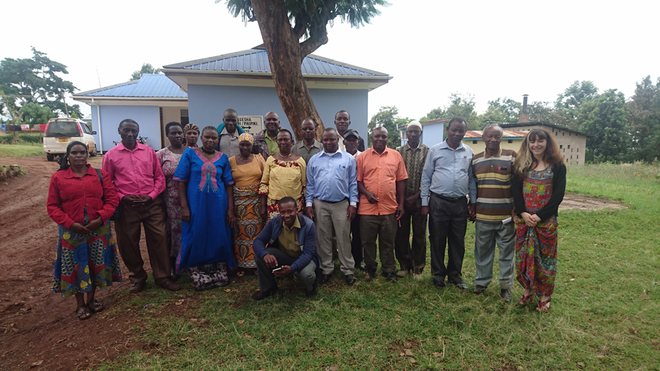

Days 2 and 3
Practical workshop attended by 14 enumerators (primary health care workers with previous training in epidemiological data collection and in census completion).
This took place at Masama health centre in the rural Hai district with the permission of the District Medical Officer Dr Haule who is supportive of the study.
This workshop was facilitated by the core team who met on Day 1, alongside a nurse from the local health centre who had been given permission to assist with the workshop and future work in order to be trained as part of the capacity building process.
The workshop was attended by enumerators from the 12 selected villages and also the enumerators from the villages included in the IDEA study (16 in total).
Summary of the workshop
Brief introduction to dementia (based on case histories and role play)
Initial thoughts of the group on use of a smartphone or tablet-based app for screening. This initial feedback was positive, and it was pointed out that some other public health initiatives in Tanzania have utilised tablets for data collection.
The use of the app was then demonstrated by the facilitators using role play based on a case histories including a very cooperative participant and informant and also demonstrating a potentially difficult participant and informant and how to address these difficulties. This is a strategy we have utilised in previous workshops and was well-received by the participants who were well engaged in giving suggestions.

Practical workshop
As part of the training process we assessed 42 older people and 30 informants who had volunteered to assist with the training. These were generally volunteers living close to the health centre, but also a small number of people living nearby and known to have dementia from a previous study. Transport was arranged for all patients and any volunteers who needed this using the project car. Participants were given refreshments and a small token payment for the time taken to come to the health centre for screening. Volunteers were only invited from villages not intended to be part of the Depec study.
We had previously sought advice from senior research staff involved in the local ethical review board who advised this training workshop would fall under the remit of permitted ‘preparatory activities’ and could take place with the local ethical review certificate in place and whilst awaiting national ethical clearance (this being the status of the DEPEC study ethics at the time of the workshop).
The purpose of this session was to give participants real life experience of using the app with individuals similar to those they would encounter in the community whilst conducting the screening and to allow any difficulties or misunderstandings with the app to be clarified.
There were some challenges to the meeting, including torrential rain occurring completely out of season and not forecast (meaning that transport home was difficult, and volunteers were unable to leave until the rains eased) and the project car breaking down and having to be repaired in the village. The rains also meant that outside spaces were not available so inside space for the workshop was limited.
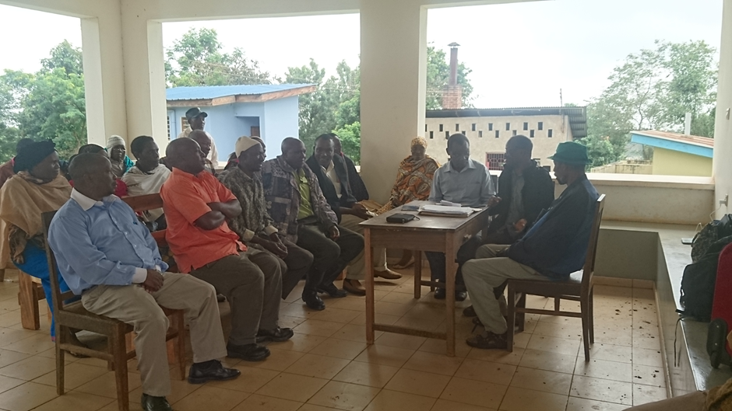

Feedback on the app from primary health care workers.
The enumerators generally thought the app was useful and easy to follow. They identified a few issues with picklists and data entry which have already been remedied. They also suggested some minor translation errors to clarify meanings etc.
A further formal forward and backward translation is under way.
Calculation of age was noted to be a major problem. In order to solve this problem a laminated sheet with year of birth and current age, alongside historical events as memory prompts will be printed and laminated to assist each enumerator in checking the age of those screened. This method has previously been validated in Africa and used in Tanzania.

A number of requests were made by the enumerators in order to carry out the dementia screening efficiently, and we agreed to meet these requests.
- A letter from the DMO to the village chairman introducing the DEPEC study to carry whilst working.
- An ID card/badge
- Copy of the ethical clearance certificate
- A project bag to carry all of the screening items in order to look official
- A stopwatch for the animals task and an emergency charger in case of electricity power cuts overnight.
- Upland village workers have requested wellington boots and an umbrella. I think this is reasonable if we are asking them to start work as the rainy season starts.

Since participants were finding use of the tablet challenging, it was agreed a member of the core team would accompany each enumerator for the first day of screening, and further days if needed until they felt confident. We have planned a half day refresher workshop run by the core team as soon as the ethical clearance is obtained for the study to start.
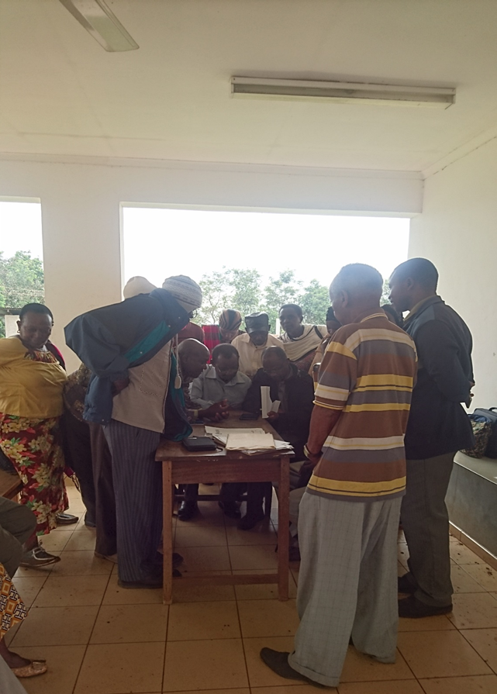

Further issues identified from analysis of the initial app data
There were some issued noted with numbering. This should resolve with refresher training and the issue to each enumerator of sequential laminated number cards to ensure study numbers not repeated. This is only an issue for the research study and not for future use in screening.
There were also some issues in calculating age from data of birth (these did not always tally) and years of education did not always tally with educational level. This issue will be addressed by prompt sheets for the initial validation study but will be an area of potential refinement of a future decision support app to be developed by the DEPEC team.

